Student name:__________
1) The study of normal body structures is called ___________.
A) physiology
B) anatomy
C) pathology
D) microscopy
E) biology
Question Details
Section : 01.01
Learning Outcome : 01.01a Define anatomy and physiology and relate them to each other.
Gradable : automatic
Accessibility : Keyboard Navigation
Topic : Scope of anatomy and physiology
Bloom's : 1. Remember
Type : Anatomy
HAPS Topic : Module A05 Basic terminology
HAPS Outcome : A05.01 Define the terms anatomy and physiology.

2) The study of how the body functions is called ___________.
A) neuroanatomy
B) anatomy
C) chemistry
D) histology
E) physiology
Question Details
Section : 01.01
Bloom's : 2. Understand
Learning Outcome : 01.01a Define anatomy and physiology and relate them to each other.
Gradable : automatic
Accessibility : Keyboard Navigation
Topic : Scope of anatomy and physiology
Type : Physiology
HAPS Topic : Module A05 Basic terminology
HAPS Outcome : A05.01 Define the terms anatomy and physiology.

3) Feeling structures with your fingertips is called __________, whereas tapping on the body and listening for sounds of abnormalities is called __________.
A) palpation;auscultation
B) auscultation;percussion
C) percussion;auscultation
D) palpation;percussion
E) percussion;palpation
Question Details
Section : 01.01
Learning Outcome : 01.01b Describe several ways of studying human anatomy.
Bloom's : 2. Understand
Gradable : automatic
Accessibility : Keyboard Navigation
Topic : Scope of anatomy and physiology
Type : Anatomy
HAPS Topic : Module A05 Basic terminology

4) Which of these is the best imaging technique for routinely examining the anatomical development of a fetus?
A) Auscultation
B) PET scan
C) MRI
D) Sonography
E) Radiography
Question Details
Section : 01.01
Learning Outcome : 01.01b Describe several ways of studying human anatomy.
Gradable : automatic
Accessibility : Keyboard Navigation
Topic : Scope of anatomy and physiology
Bloom's : 1. Remember
Type : Anatomy

5) The study of the structure and function of cells is called __________.
A) cytology
B) gross anatomy
C) exploratoryphysiology
D) comparativephysiology
E) radiology
Question Details
Section : 01.01
Learning Outcome : 01.01b Describe several ways of studying human anatomy.
Gradable : automatic
Accessibility : Keyboard Navigation
Topic : Scope of anatomy and physiology
Bloom's : 1. Remember
Type : Anatomy
Type : Physiology
HAPS Topic : Module A06 Levels of organization
HAPS Outcome : A06.01 Describe, in order from simplest to most complex, the major levels of organizat

6) Ultrastructure refers to the detailed structure to the level of the ___________.
A) molecule
B) cell
C) organelle
D) tissue
E) organ
Question Details
Section : 01.01
Learning Outcome : 01.01b Describe several ways of studying human anatomy.
Bloom's : 2. Understand
Gradable : automatic
Accessibility : Keyboard Navigation
Topic : Scope of anatomy and physiology
Type : Anatomy
HAPS Topic : Module A06 Levels of organization
HAPS Outcome : A06.01 Describe, in order from simplest to most complex, the major levels of organizat

7) The study of how hormones function is called ____________.
A) neuroanatomy
B) neurophysiology
C) endocrinology
D) histology
E) pathophysiology
Question Details
Section : 01.01
Bloom's : 2. Understand
Learning Outcome : 01.01c Define a few subdisciplines of human physiology.
Gradable : automatic
Accessibility : Keyboard Navigation
Topic : Scope of anatomy and physiology
Type : Physiology
HAPS Topic : Module A07 Survey of body systems
HAPS Outcome : A07.02 Describe the major functions of each organ system.

8) The study of mechanism of disease is called __________.
A) neuroanatomy
B) neurophysiology
C) endocrinology
D) histology
E) pathophysiology
Question Details
Section : 01.01
Bloom's : 2. Understand
Learning Outcome : 01.01c Define a few subdisciplines of human physiology.
Gradable : automatic
Accessibility : Keyboard Navigation
Topic : Scope of anatomy and physiology
Type : Physiology
HAPS Topic : Module A05 Basic terminology

9) The terms physics, physiology, and physician come from a term __________ proposed to distinguish natural causes from supernatural causes.
A) Hippocrates
B) Plato
C) Schwann
D) Aristotle
E) Avicenna
Question Details
Section : 01.02
Learning Outcome : 01.02b Describe the contributions of some key people who helped to bring about thi
Learning Outcome : 01.02a Give examples of how modern biomedical science emerged from an era of super
Gradable : automatic
Accessibility : Keyboard Navigation
Topic : Origins of biomedical science
Bloom's : 1. Remember
Type : Physiology
HAPS Topic : Module A05 Basic terminology

10) Who was a physician to the Roman gladiators, learned by dissection of animals, and saw science as a method of discovery?
A) Hippocrates
B) Plato
C) Schwann
D) Aristotle
E) Galen
Question Details
Section : 01.02
Learning Outcome : 01.02b Describe the contributions of some key people who helped to bring about thi
Learning Outcome : 01.02a Give examples of how modern biomedical science emerged from an era of super
Gradable : automatic
Accessibility : Keyboard Navigation
Topic : Origins of biomedical science
Bloom's : 1. Remember

11) Knownas "the father of modern anatomy," __________ was the first to publish accurate drawings of the body.
A) Vesalius
B) Maimonides
C) Harvey
D) Aristotle
E) van Leeuwenhoek
Question Details
Section : 01.02
Learning Outcome : 01.02b Describe the contributions of some key people who helped to bring about thi
Gradable : automatic
Accessibility : Keyboard Navigation
Topic : Origins of biomedical science
Bloom's : 1. Remember
Type : Anatomy

12) The most influential medical textbook of the ancient era was written by __________.
A) Hippocrates
B) Aristotle
C) Galen
D) Vesalius
E) Avicenna
Question Details
Section : 01.02
Learning Outcome : 01.02b Describe the contributions of some key people who helped to bring about thi
Gradable : automatic
Accessibility : Keyboard Navigation
Topic : Origins of biomedical science
Bloom's : 1. Remember
Type : Anatomy

13) Who established a code of ethics for physicians and is considered the "father of medicine"?
A) Aristotle
B) Hippocrates
C) Galen
D) Vesalius
E) Hooke
Question Details
Section : 01.02
Learning Outcome : 01.02b Describe the contributions of some key people who helped to bring about thi
Gradable : automatic
Accessibility : Keyboard Navigation
Topic : Origins of biomedical science
Bloom's : 1. Remember
Type : Anatomy

14) What is the process of using numerous observations to develop general principles and predictions about a specific subject called?
A) Experimental design
B) The deductive method
C) The inductive method
D) A hypothesis
E) Statistical testing
Question Details
Section : 01.03
Learning Outcome : 01.03a Describe the inductive and hypothetico-deductive methods of obtaining scien
Bloom's : 2. Understand
Gradable : automatic
Accessibility : Keyboard Navigation
Topic : Scientific Method

15) Most people think that ulcers are caused by psychological stress. It was discovered that an acid-resistant bacterium, Heliobacter pylori, lives in the lining of the stomach. If these bacteria cause ulcers, then treatment with an antibiotic should reduce ulcers. This line of investigation is an example of __________.
A) hypotheticalreasoning
B) hypothetico-deductive reasoning
C) the inductivemethod
D) experimentaldesign
E) statisticalanalysis
Question Details
Bloom's : 3. Apply
Section : 01.03
Learning Outcome : 01.03a Describe the inductive and hypothetico-deductive methods of obtaining scien
Gradable : automatic
Accessibility : Keyboard Navigation
Topic : Scientific Method
Type : Physiology

16) The use of controls and statistical testing are two aspects of experimental design that help to ensure __________.
A) an adequate samplesize
B) objective andreliable results
C) experimentalbias
D) psychosomaticeffects
E) treatmentgroups
Question Details
Bloom's : 3. Apply
Section : 01.03
Learning Outcome : 01.03b Describe some aspects of experimental design that help to ensure objective
Gradable : automatic
Accessibility : Keyboard Navigation
Topic : Scientific Method

17) Which process submits a scientist's ideas to the critical judgment of other specialists in the field before the research is funded or published?
A) Adjudication
B) Statistical testing
C) Falsification
D) Peer review
E) Hypothetico-deductive testing
Question Details
Section : 01.03
Learning Outcome : 01.03b Describe some aspects of experimental design that help to ensure objective
Gradable : automatic
Accessibility : Keyboard Navigation
Topic : Scientific Method
Bloom's : 1. Remember

18) A new drug apparently increases short-term memory. Students were divided randomly into two groups at the beginning of the semester. One group was given the memory pill once a day for the semester, and the other group was given a same-looking pill, but it was just sugar. The sugar pill is termed a(n) __________.
A) controlledpill
B) placebo
C) treatmentpill
D) variable
E) effectivedose
Question Details
Bloom's : 3. Apply
Section : 01.03
Learning Outcome : 01.03b Describe some aspects of experimental design that help to ensure objective
Gradable : automatic
Accessibility : Keyboard Navigation
Topic : Scientific Method

19) Two groups of people were tested to determine whether garlic lowers blood cholesterol levels. One group was given 800 mg of garlic powder daily for four months and exhibited an average 12% reduction in the blood cholesterol. The other group was not given any garlic and after four months averaged a 3% reduction in cholesterol. The group that was not given the garlic was the __________ group.
A) peer
B) test
C) treatment
D) control
E) double-blind
Question Details
Bloom's : 3. Apply
Section : 01.03
Learning Outcome : 01.03b Describe some aspects of experimental design that help to ensure objective
Gradable : automatic
Accessibility : Keyboard Navigation
Topic : Scientific Method

20) An educated speculation or a possible answer to a question is called a(n) __________.
A) scientificmethod
B) theory
C) law
D) hypothesis
E) fact
Question Details
Section : 01.03
Bloom's : 2. Understand
Learning Outcome : 01.03c Explain what is meant by hypothesis, fact, law, and theory in science.
Gradable : automatic
Accessibility : Keyboard Navigation
Topic : Scientific Method
HAPS Topic : Module A05 Basic terminology

21) Which of the following would contain the greatest amount of information that scientists consider to be true to the best of their knowledge?
A) A fact
B) A law ofnature
C) A hypothesis
D) An equation
E) A theory
Question Details
Bloom's : 3. Apply
Section : 01.03
Learning Outcome : 01.03c Explain what is meant by hypothesis, fact, law, and theory in science.
Gradable : automatic
Accessibility : Keyboard Navigation
Topic : Scientific Method
HAPS Topic : Module A05 Basic terminology

22) If a species of animal evolves over generations to grow a large fan-blade like growth on its back to catch the wind and cool its body, this would be an example of responding to __________.
A) selection pressure
B) adaptation
C) natural selection
D) climate change
E) positive feedback
Question Details
Bloom's : 3. Apply
Section : 01.04
Learning Outcome : 01.04a Explain why evolution is relevant to understanding human form and function.
Gradable : automatic
Accessibility : Keyboard Navigation
Topic : Human origins and adaptations

23) What is a change in the genetic composition of a population over time called?
A) Mutation
B) Natural selection
C) Selection pressure
D) Evolution
E) Adaptation
Question Details
Section : 01.04
Learning Outcome : 01.04b Define evolution and natural selection.
Gradable : automatic
Accessibility : Keyboard Navigation
Topic : Human origins and adaptations
Bloom's : 1. Remember

24) The constant appearance of new strains of influenza virus is an example of __________.
A) a model
B) evolution
C) selectionpressure
D) survivorship
E) success
Question Details
Bloom's : 3. Apply
Section : 01.04
Learning Outcome : 01.04b Define evolution and natural selection.
Gradable : automatic
Accessibility : Keyboard Navigation
Topic : Human origins and adaptations

25) What is the principal theory of how evolution works?
A) Natural pressure
B) Selective pressure
C) Darwinian pressure
D) Natural adaptation
E) Natural selection
Question Details
Section : 01.04
Learning Outcome : 01.04b Define evolution and natural selection.
Gradable : automatic
Accessibility : Keyboard Navigation
Topic : Human origins and adaptations
Bloom's : 1. Remember

26) Stereoscopic vision provides __________.
A) opposableperception
B) colorperception
C) depthperception
D) bipedalism
E) opposition of thumbs
Question Details
Section : 01.04
Learning Outcome : 01.04c Describe some human characteristics that can be attributed to the tree-dwel
Gradable : automatic
Accessibility : Keyboard Navigation
Topic : Human origins and adaptations
Bloom's : 1. Remember
Type : Anatomy

27) Most primates are __________, meaning they live in trees.
A) prehensile
B) bipedal
C) cursorial
D) troglodytic
E) arboreal
Question Details
Section : 01.04
Learning Outcome : 01.04c Describe some human characteristics that can be attributed to the tree-dwel
Gradable : automatic
Accessibility : Keyboard Navigation
Topic : Human origins and adaptations
Bloom's : 1. Remember

28) Which of the following was an adaptation thatevolved in connection with human upright walking?
A) Hair
B) Fully opposablethumbs
C) Stereoscopicvision
D) Color vision
E) Spinal and pelvicanatomy
Question Details
Bloom's : 2. Understand
Section : 01.04
Learning Outcome : 01.04d Describe some human characteristics that evolved later in connection with u
Gradable : automatic
Accessibility : Keyboard Navigation
Topic : Human origins and adaptations

29) A human is born before his/her nervous system has matured. This is traceable to __________.
A) their inabilityto regulate body temperature
B) skeletaladaptations to bipedalism
C) the arborealhabits of early primates
D) the conditions ofmodern civilization
E) the diet of earlyspecies of Homo
Question Details
Bloom's : 2. Understand
Section : 01.04
Learning Outcome : 01.04d Describe some human characteristics that evolved later in connection with u
Gradable : automatic
Accessibility : Keyboard Navigation
Topic : Human origins and adaptations
Type : Physiology

30) What is the species of modern humans?
A) Homo erectus
B) Homo sapiens
C) Homo habilis
D) Neanderthal
E) Australopithecus
Question Details
Section : 01.04
Learning Outcome : 01.04d Describe some human characteristics that evolved later in connection with u
Gradable : automatic
Accessibility : Keyboard Navigation
Topic : Human origins and adaptations
Bloom's : 1. Remember

31) An __________ is composed of two or more tissues types, whereas __________ are microscopic structures in a cell.
A) organ system;organs
B) organ system;organelles
C) organ;organelles
D) organ;molecules
E) organelle;molecules
Question Details
Bloom's : 2. Understand
Section : 01.05
Learning Outcome : 01.05a List the levels of human structure from the most complex to the simplest.
Gradable : automatic
Accessibility : Keyboard Navigation
Topic : Scope of anatomy and physiology
Type : Anatomy
HAPS Topic : Module A06 Levels of organization
HAPS Outcome : A06.01 Describe, in order from simplest to most complex, the major levels of organizat

32) Which of the following lists levels of human structure from the most complex to the simplest?
A) Organelle, cell,tissue, organ, organ system
B) Organ system,organ, cell, tissue, organelle
C) Organ system,organelle, tissue, cell, organ
D) Organ system,organ, tissue, cell, organelle
E) Organ, organsystem, tissue, cell, organelle
Question Details
Bloom's : 2. Understand
Section : 01.05
Learning Outcome : 01.05a List the levels of human structure from the most complex to the simplest.
Gradable : automatic
Accessibility : Keyboard Navigation
Topic : Scope of anatomy and physiology
Type : Anatomy
HAPS Topic : Module A06 Levels of organization
HAPS Outcome : A06.01 Describe, in order from simplest to most complex, the major levels of organizat

33) Which of the followinglists examples of body structures from the simplest to the most complex?
A) Mitochondrion,connective tissue, protein, stomach, adipocyte (fat cell)
B) Protein,mitochondrion, adipocyte (fat cell), connective tissue, stomach
C) Mitochondrion,connective tissue, stomach, protein, adipocyte (fat cell)
D) Protein,adipocyte (fat cell), stomach, connective tissue, mitochondrion
E) Protein, stomach,connective tissue, adipocyte (fat cell), mitochondrion
Question Details
Bloom's : 3. Apply
Section : 01.05
Learning Outcome : 01.05a List the levels of human structure from the most complex to the simplest.
Gradable : automatic
Accessibility : Keyboard Navigation
Topic : Scope of anatomy and physiology
Type : Anatomy
HAPS Topic : Module A06 Levels of organization
HAPS Outcome : A06.01 Describe, in order from simplest to most complex, the major levels of organizat

34) A(n) __________ is a group of similar cells and their intercellular materials in a discrete region of an organ performing a specific function.
A) macromolecule
B) organ system
C) organelle
D) organism
E) tissue
Question Details
Section : 01.05
Learning Outcome : 01.05a List the levels of human structure from the most complex to the simplest.
Gradable : automatic
Accessibility : Keyboard Navigation
Topic : Scope of anatomy and physiology
Bloom's : 1. Remember
Type : Anatomy
HAPS Topic : Module A06 Levels of organization
HAPS Outcome : A06.01 Describe, in order from simplest to most complex, the major levels of organizat

35) All of the following are human organ systems except __________.
A) skeletal
B) endocrine
C) epidermal
D) reproductive
E) lymphatic
Question Details
Bloom's : 3. Apply
Section : 01.05
Learning Outcome : 01.05a List the levels of human structure from the most complex to the simplest.
Gradable : automatic
Accessibility : Keyboard Navigation
Topic : Scope of anatomy and physiology
Type : Anatomy
HAPS Topic : Module A07 Survey of body systems
HAPS Outcome : A07.01 List the organ systems of the human body and their major components.

36) All of the following are organs except __________.
A) teeth
B) the skin
C) nails
D) the liver
E) the digestivesystem
Question Details
Bloom's : 2. Understand
Section : 01.05
Learning Outcome : 01.05a List the levels of human structure from the most complex to the simplest.
Gradable : automatic
Accessibility : Keyboard Navigation
Topic : Scope of anatomy and physiology
Type : Anatomy
HAPS Topic : Module A06 Levels of organization
HAPS Outcome : A06.02 Give an example of each level of organization.

37) Taking apart a clock to see how it works is similar to __________ thinking about human physiology.
A) comparative
B) evolutionary
C) holistic
D) inductive
E) reductionist
Question Details
Bloom's : 3. Apply
Section : 01.05
Learning Outcome : 01.05b Discuss the value of both reductionistic and holistic viewpoints to underst
Gradable : automatic
Accessibility : Keyboard Navigation
Topic : Scope of anatomy and physiology
Type : Physiology
HAPS Topic : Module A05 Basic terminology
HAPS Outcome : A05.01 Define the terms anatomy and physiology.

38) Which of the following approaches understanding the human body by studying the interactions of its parts?
A) Naturalism
B) Reductionism
C) Vitalism
D) Holism
E) Rationalism
Question Details
Section : 01.05
Learning Outcome : 01.05b Discuss the value of both reductionistic and holistic viewpoints to underst
Gradable : automatic
Accessibility : Keyboard Navigation
Topic : Scope of anatomy and physiology
Bloom's : 1. Remember
Type : Physiology

39) What is the view that not everything about an organism can be understood or predicted from the knowledge of its components; that is, the whole is greater than the sum of its parts?
A) Naturalism
B) Reductionism
C) Holism
D) Materialism
E) Science
Question Details
Section : 01.05
Learning Outcome : 01.05b Discuss the value of both reductionistic and holistic viewpoints to underst
Gradable : automatic
Accessibility : Keyboard Navigation
Topic : Scope of anatomy and physiology
Bloom's : 1. Remember
Type : Physiology

40) The fact that most of us have five lumbar vertebrae, but some people have six and some have four, is an example of what type of variation among organisms?
A) Cellular
B) Holistic
C) Physiological
D) Anatomical
E) Reductionist
Question Details
Bloom's : 3. Apply
Section : 01.05
Learning Outcome : 01.05c Discuss the clinical significance of anatomical variation among humans.
Gradable : automatic
Accessibility : Keyboard Navigation
Topic : Scope of anatomy and physiology
Type : Anatomy
HAPS Topic : Module A05 Basic terminology

41) Why does a surgeon need to be familiar with different versions of anatomy?
A) Cellular adaptation
B) Holistic medicine
C) Physiological variation
D) Anatomical variation
E) Evolutionary adaptation
Question Details
Bloom's : 3. Apply
Section : 01.05
Learning Outcome : 01.05c Discuss the clinical significance of anatomical variation among humans.
Gradable : automatic
Accessibility : Keyboard Navigation
Topic : Scope of anatomy and physiology
Type : Anatomy

42) What are the simplest body structures considered alive?
A) Organ systems
B) Organs
C) Cells
D) Organelles
E) Molecules
Question Details
Section : 01.05
Learning Outcome : 01.06a State the characteristics that distinguish living organisms from nonliving
Gradable : automatic
Accessibility : Keyboard Navigation
Topic : Scope of anatomy and physiology
Bloom's : 1. Remember
Type : Anatomy
HAPS Topic : Module A06 Levels of organization
HAPS Outcome : A06.01 Describe, in order from simplest to most complex, the major levels of organizat

43) Metabolism is the sum of all __________ change.
A) external physical
B) external chemical
C) internal chemical
D) internal physical
E) internal integrative
Question Details
Section : 01.06
Learning Outcome : 01.06a State the characteristics that distinguish living organisms from nonliving
Gradable : automatic
Accessibility : Keyboard Navigation
Topic : Scope of anatomy and physiology
Bloom's : 1. Remember
Type : Physiology
HAPS Topic : Module A06 Levels of organization
HAPS Outcome : A06.02 Give an example of each level of organization.

44) The change in size of the bone marrow (where blood cells are produced) as an infant matures is an example of __________, whereas the transformation of blood stem cells into white blood cells is an example of __________.
A) development;differentiation
B) growth;development
C) growth;differentiation
D) differentiation;growth
E) differentiation;development
Question Details
Bloom's : 3. Apply
Section : 01.06
Learning Outcome : 01.06a State the characteristics that distinguish living organisms from nonliving
Gradable : automatic
Accessibility : Keyboard Navigation
Topic : Scope of anatomy and physiology
Type : Physiology

45) A hemoglobin level of 12g/dL is normal for an adult female, but low for an adult male. What is this is an example of?
A) Cellular adaptation
B) Holistic medicine
C) Physiological variation
D) Anatomical variation
E) Structural differentiation
Question Details
Bloom's : 3. Apply
Section : 01.06
Learning Outcome : 01.06b Explain the importance of physiological variation among persons
Gradable : automatic
Accessibility : Keyboard Navigation
Topic : Scope of anatomy and physiology
Type : Physiology

46) Which of the following is not an aspectthat could result in physiological variation?
A) Age
B) Gender
C) Environment
D) Physicalactivity
E) These are allaspects that can cause physiological variation.
Question Details
Bloom's : 3. Apply
Section : 01.06
Learning Outcome : 01.06b Explain the importance of physiological variation among persons
Gradable : automatic
Accessibility : Keyboard Navigation
Topic : Scope of anatomy and physiology
Type : Physiology

47) We live in an ever-changing environment outside of our body, yet our internal conditions remain relatively stable. This is called __________.
A) homeostasis
B) metastasis
C) responsiveness
D) adaptation
E) evolution
Question Details
Bloom's : 2. Understand
Section : 01.06
Learning Outcome : 01.06c Define homeostasis and explain why this concept is central to physiology.
Gradable : automatic
Accessibility : Keyboard Navigation
Topic : Definition of homeostasis
Type : Physiology
HAPS Topic : Module B01 Definition of Homeostasis
HAPS Outcome : B01.01 Define homeostasis.

48) What are the three common components of a feedback loop?
A) Stimulus, integrating (control) center, and organ system
B) Stimulus, receptor, and integrating (control) center
C) Receptor, integrating (control) center, and effector
D) Receptor, organ, and organ system
E) Receptor, integrating (control) center, and organ system
Question Details
Bloom's : 2. Understand
Section : 01.06
Learning Outcome : 01.06c Define homeostasis and explain why this concept is central to physiology.
Gradable : automatic
Accessibility : Keyboard Navigation
Topic : Types of homeostatic mechanisms
Type : Physiology
HAPS Topic : Module B02 General types of homeostatic mechanisms
HAPS Outcome : B02.02 List the steps in a feedback mechanism (loop) and explain the function of each

49) During exercise, one generates excess heat and the body temperature rises. As a response, blood vessels dilate in the skin, warm blood flows closer to the body surface, and heat is lost. This is an example of__________.
A) negativefeedback
B) positivefeedback
C) dynamicequilibrium
D) integrationcontrol
E) set pointadjustment
Question Details
Bloom's : 3. Apply
Section : 01.06
Learning Outcome : 01.06d Define negative feedback, give an example of it, and explain its importance
Gradable : automatic
Accessibility : Keyboard Navigation
Topic : Examples of homeostatic mechanisms
Type : Physiology
HAPS Topic : Module B02 General types of homeostatic mechanisms
HAPS Outcome : B02.03 Compare and contrast positive and negative feedback in terms of the relationshi

50) Blood glucose concentration rises after a meal and stimulates the pancreas to release the hormone insulin. Insulin travels in the blood and stimulates the uptake ofglucose by body cells from the bloodstream, thusreducing blood glucose concentration. This is an example of _________.
A) negativefeedback
B) positivefeedback
C) dynamicequilibrium
D) integrationcontrol
E) set pointadjustment
Question Details
Bloom's : 3. Apply
Section : 01.06
Learning Outcome : 01.06d Define negative feedback, give an example of it, and explain its importance
Gradable : automatic
Accessibility : Keyboard Navigation
Topic : Examples of homeostatic mechanisms
Type : Physiology
HAPS Topic : Module B02 General types of homeostatic mechanisms
HAPS Outcome : B02.03 Compare and contrast positive and negative feedback in terms of the relationshi

51) Negative feedback loops are __________.
A) homeostaticmechanisms
B) not homeostaticmechanisms
C) associated with"vicious circles"
D) self-amplifyingcycles
E) usually harmful
Question Details
Section : 01.06
Learning Outcome : 01.06d Define negative feedback, give an example of it, and explain its importance
Gradable : automatic
Accessibility : Keyboard Navigation
Topic : Types of homeostatic mechanisms
Bloom's : 1. Remember
Type : Physiology
HAPS Topic : Module B02 General types of homeostatic mechanisms
HAPS Outcome : B02.03 Compare and contrast positive and negative feedback in terms of the relationshi

52) When a woman is giving birth, the head of the baby pushes against her cervix and stimulates therelease of the hormone oxytocin. Oxytocin travels in the blood and stimulates the uterus to contract. Labor contractions become more and more intense until the baby is expelled. This is an example of __________.
A) negativefeedback
B) positivefeedback
C) dynamicequilibrium
D) integrationcontrol
E) set pointadjustment
Question Details
Bloom's : 3. Apply
Section : 01.06
Learning Outcome : 01.06e Define positive feedback and give examples of its beneficial and harmful ef
Gradable : automatic
Accessibility : Keyboard Navigation
Topic : Examples of homeostatic mechanisms
Type : Physiology
HAPS Topic : Module B02 General types of homeostatic mechanisms
HAPS Outcome : B02.03 Compare and contrast positive and negative feedback in terms of the relationshi

53) Which of the following is most likely to cause disease?
A) Positivefeedback
B) Negativefeedback
C) Homeostasis
D) Equilibrium
E) Irritability
Question Details
Bloom's : 2. Understand
Section : 01.06
Learning Outcome : 01.06e Define positive feedback and give examples of its beneficial and harmful ef
Gradable : automatic
Accessibility : Keyboard Navigation
Topic : Types of homeostatic mechanisms
Type : Physiology
HAPS Topic : Module B02 General types of homeostatic mechanisms
HAPS Outcome : B02.03 Compare and contrast positive and negative feedback in terms of the relationshi

54) A physiological __________ is a difference in chemical concentration, electrical charge, physical pressure, temperature, or other variables between one point and another.
A) gradient
B) barrier
C) membrane
D) imbalance
E) feedback loop
Question Details
Section : 01.06
Learning Outcome : 01.06f Define gradient, describe the variety of gradients in human physiology, and
Gradable : automatic
Accessibility : Keyboard Navigation
Topic : Scope of anatomy and physiology
Bloom's : 1. Remember
Type : Physiology

55) Chemicals in a solution can move down a concentration gradient. This means the chemical will move from the area of__________ concentrationto the area of_________ concentration.
A) higher; lower
B) lower; higher
C) equal; equal
D) lower; lower
E) higher; higher
Question Details
Bloom's : 2. Understand
Section : 01.06
Learning Outcome : 01.06f Define gradient, describe the variety of gradients in human physiology, and
Gradable : automatic
Accessibility : Keyboard Navigation
Topic : Scope of anatomy and physiology
Type : Physiology

56) Which of the following is not an example of a physiological gradient?
A) Tissue
B) Thermal
C) Concentration
D) Pressure
E) Electrical
Question Details
Bloom's : 2. Understand
Section : 01.06
Learning Outcome : 01.06f Define gradient, describe the variety of gradients in human physiology, and
Gradable : automatic
Accessibility : Keyboard Navigation
Topic : Scope of anatomy and physiology
Type : Physiology

57) What type of gradient causes the movement of ions due to both charge and concentration differences?
A) Electrochemical gradient
B) Thermal gradient
C) Concentration gradient
D) Pressure gradient
E) Osmotic gradient
Question Details
Bloom's : 3. Apply
Section : 01.06
Learning Outcome : 01.06f Define gradient, describe the variety of gradients in human physiology, and
Gradable : automatic
Accessibility : Keyboard Navigation
Topic : Scope of anatomy and physiology
Type : Physiology

58) Modern anatomical language is based on what two languages because individuals speaking these languages made most of the early anatomical discoveries?
A) Greek and Latin
B) English and Japanese
C) English and Spanish
D) Roman and Latin
E) Latin and Chinese
Question Details
Section : 01.07
Learning Outcome : 01.07a Explain why modern anatomical terminology is so heavily based on Greek and
Learning Outcome : 01.07c Describe the efforts to achieve an internationally uniform anatomical termi
Gradable : automatic
Accessibility : Keyboard Navigation
Topic : Scope of anatomy and physiology
Bloom's : 1. Remember
Type : Anatomy
HAPS Topic : Module A05 Basic terminology

59) The term fallopian tube (uterine tube) is an example of __________.
A) a Latin root usedin medical terminology
B) the use ofprefixes to name an anatomical structure
C) the use ofsuffixes to name an anatomical structure
D) an eponym
E) an acronym
Question Details
Section : 01.07
Learning Outcome : 01.07b Recognize eponyms when you see them.
Gradable : automatic
Accessibility : Keyboard Navigation
Topic : Scope of anatomy and physiology
Bloom's : 1. Remember
Type : Anatomy
HAPS Topic : Module A05 Basic terminology

60) The lexicon of standard international anatomical terms is __________.
A) called Terminologia Anatomica (TA)
B) called Nomina Anatomica (NA)
C) formed fromthousands of English word roots
D) formed fromthousands of Italian word roots
E) formed fromthousands of French word roots
Question Details
Section : 01.07
Learning Outcome : 01.07c Describe the efforts to achieve an internationally uniform anatomical termi
Gradable : automatic
Accessibility : Keyboard Navigation
Topic : Scope of anatomy and physiology
Bloom's : 1. Remember
Type : Anatomy
HAPS Topic : Module A05 Basic terminology

61) The prefix hypo- means __________, whereas hyper- means __________.
A) front; back
B) right; left
C) inside;outside
D) clear; dark
E) below; above
Question Details
Section : 01.07
Learning Outcome : 01.07d Break medical terms down into their basic word elements.
Gradable : automatic
Accessibility : Keyboard Navigation
Topic : Scope of anatomy and physiology
Bloom's : 1. Remember
Type : Anatomy
HAPS Topic : Module A05 Basic terminology

62) What does "hypercalcemia" mean?
A) Elevated calcium levels
B) Lowered calcium levels
C) Elevated sodium levels
D) Lowered sodium levels
E) Elevated potassium levels
Question Details
Bloom's : 2. Understand
Section : 01.07
Learning Outcome : 01.07d Break medical terms down into their basic word elements.
Gradable : automatic
Accessibility : Keyboard Navigation
Topic : Scope of anatomy and physiology
Type : Physiology
HAPS Topic : Module A05 Basic terminology

63) DNA is an example of an __________, whereas PET scan is an example of an __________.
A) abbreviation;acronym
B) acronym;abbreviation
C) eponym;acronym
D) acronym;eponym
E) eponym;abbreviation
Question Details
Bloom's : 3. Apply
Section : 01.07
Learning Outcome : 01.07e State some reasons why the literal meaning of a word may not lend to insigh
Gradable : automatic
Accessibility : Keyboard Navigation
Topic : Scope of anatomy and physiology
Type : Anatomy
HAPS Topic : Module A05 Basic terminology

64) The plural of axilla (armpit) is __________, whereas the plural of appendix is __________.
A) axillae;appendices
B) axillides;appendages
C) axillies;appendi
D) axilli;appendices
E) axilles; appendices
Question Details
Bloom's : 2. Understand
Section : 01.07
Learning Outcome : 01.07f Relate singular noun forms to their plural and adjectival forms.
Gradable : automatic
Accessibility : Keyboard Navigation
Topic : Scope of anatomy and physiology
Type : Anatomy
HAPS Topic : Module A05 Basic terminology

65) The plural of villus (hair) is __________, whereas the plural of diagnosis is __________.
A) villuses;diagnosises
B) villi;diagnoses
C) villus;diagnosis
D) villi;diagnosis
E) villuses;diagnosis
Question Details
Bloom's : 2. Understand
Section : 01.07
Learning Outcome : 01.07f Relate singular noun forms to their plural and adjectival forms.
Gradable : automatic
Accessibility : Keyboard Navigation
Topic : Scope of anatomy and physiology
Type : Anatomy
HAPS Topic : Module A05 Basic terminology

66) Why is precise spelling important in anatomy?
A) It is important to practice language skills.
B) There are many different ways to spell certain terms.
C) Eponyms are difficult to memorize.
D) There are many similar terms in anatomy that refer to different structures.
E) It is easier to remember acronyms when spelled correctly.
Question Details
Bloom's : 2. Understand
Section : 01.07
Learning Outcome : 01.07g Discuss why precise spelling is important in anatomy and physiology
Gradable : automatic
Accessibility : Keyboard Navigation
Topic : Scope of anatomy and physiology
Type : Anatomy
HAPS Topic : Module A05 Basic terminology

67) The ileum is __________, whereasthe ilium is ____________.
A) part of the hip bone; part of the small intestine
B) part of the smallintestine; part of the hip bone
C) a bone in thewrist; a muscle of the back
D) a muscle; abone
E) a bone; amuscle
Question Details
Bloom's : 2. Understand
Section : 01.07
Learning Outcome : 01.07g Discuss why precise spelling is important in anatomy and physiology
Gradable : automatic
Accessibility : Keyboard Navigation
Topic : Scope of anatomy and physiology
Type : Anatomy
HAPS Topic : Module A05 Basic terminology

68) What is the name of the highlighted organ?
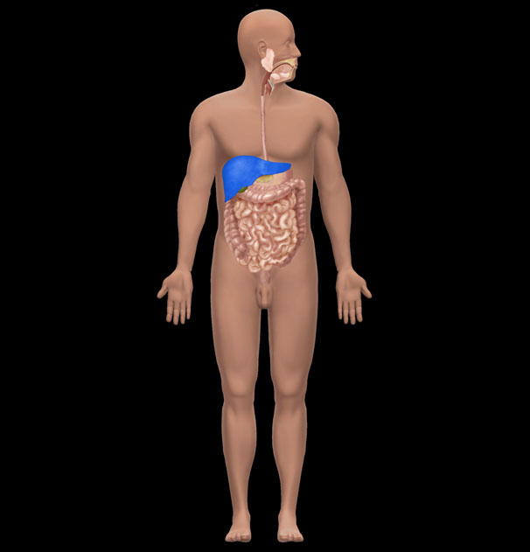
A) Small intestine
B) Stomach
C) Liver
D) Largeintestine
E) Spleen
Question Details
Section : 01.05
Learning Outcome : 01.05a List the levels of human structure from the most complex to the simplest.
Gradable : automatic
Bloom's : 1. Remember
Type : New
Type : Anatomy
HAPS Topic : Module A06 Levels of organization
HAPS Outcome : A06.02 Give an example of each level of organization.
Topic : Body Orientation
Source : APR

69) What is the name of the highlighted organ?
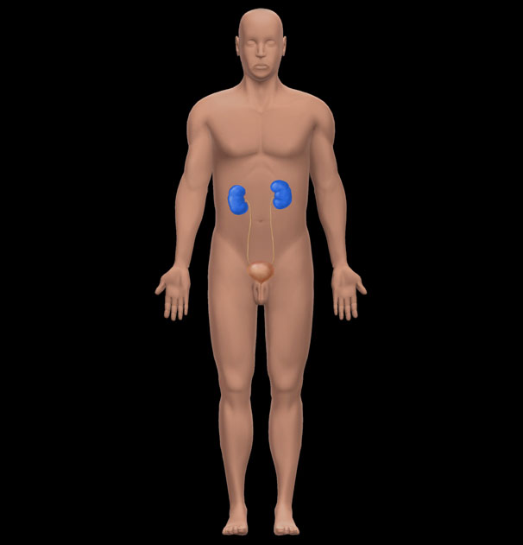
A) Adrenal gland
B) Spleen
C) Liver
D) Kidney
E) Pancreas
Question Details
Section : 01.05
Learning Outcome : 01.05a List the levels of human structure from the most complex to the simplest.
Gradable : automatic
Bloom's : 1. Remember
Type : New
Type : Anatomy
HAPS Topic : Module A06 Levels of organization
HAPS Outcome : A06.02 Give an example of each level of organization.
Topic : Body Orientation
Source : APR

70) 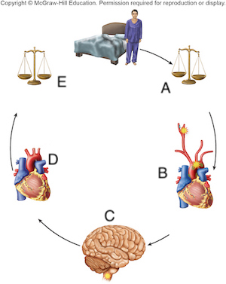
Question Details
Type : New
Type : Physiology
Figure : 01.08

70.1) Which letter represents the receptor of this feedback loop?
A) A
B) B
C) C
D) D
E) E
Question Details
Bloom's : 2. Understand
Section : 01.06
Learning Outcome : 01.06d Define negative feedback, give an example of it, and explain its importance
Topic : Types of homeostatic mechanisms
Type : New
Type : Physiology
HAPS Topic : Module B02 General types of homeostatic mechanisms
HAPS Outcome : B02.02 List the steps in a feedback mechanism (loop) and explain the function of each
Figure : 01.08

70.2) Which letter represents the effectorof this feedback loop?
A) A
B) B
C) C
D) D
E) E
Question Details
Bloom's : 2. Understand
Section : 01.06
Learning Outcome : 01.06d Define negative feedback, give an example of it, and explain its importance
Topic : Types of homeostatic mechanisms
Type : New
Type : Physiology
HAPS Topic : Module B02 General types of homeostatic mechanisms
HAPS Outcome : B02.02 List the steps in a feedback mechanism (loop) and explain the function of each
Figure : 01.08

70.3) Where in this feedback loop is homeostasis present?
A) A
B) B
C) C
D) D
E) E
Question Details
Bloom's : 2. Understand
Section : 01.06
Learning Outcome : 01.06d Define negative feedback, give an example of it, and explain its importance
Topic : Types of homeostatic mechanisms
Type : New
Type : Physiology
HAPS Topic : Module B02 General types of homeostatic mechanisms
HAPS Outcome : B02.02 List the steps in a feedback mechanism (loop) and explain the function of each
Figure : 01.08

70.4) This feedback loop is an example of which of the following?
A) Negative feedback
B) Positive feedback
C) Dynamic equilibrium
D) Thermal gradient
E) Natural selection
Question Details
Bloom's : 2. Understand
Section : 01.06
Learning Outcome : 01.06d Define negative feedback, give an example of it, and explain its importance
Topic : Types of homeostatic mechanisms
Type : New
Type : Physiology
HAPS Topic : Module B02 General types of homeostatic mechanisms
HAPS Outcome : B02.02 List the steps in a feedback mechanism (loop) and explain the function of each
Figure : 01.08

71) 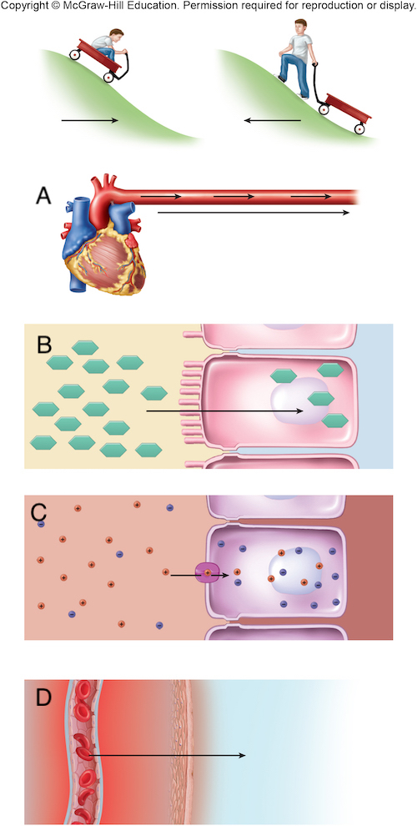
Question Details
Section : 01.06
Learning Outcome : 01.06f Define gradient, describe the variety of gradients in human physiology, and
Bloom's : 1. Remember
Type : New
Type : Physiology
Figure : 01.10

71.1) Which letter represents a pressuregradient?
A) A
B) B
C) C
D) D
E) All of these represent a pressure gradient.
Question Details
Section : 01.06
Learning Outcome : 01.06f Define gradient, describe the variety of gradients in human physiology, and
Bloom's : 1. Remember
Type : New
Type : Physiology
Figure : 01.10

71.2) Which letter represents a thermalgradient?
A) A
B) B
C) C
D) D
E) All of these represent a thermal gradient.
Question Details
Section : 01.06
Learning Outcome : 01.06f Define gradient, describe the variety of gradients in human physiology, and
Bloom's : 1. Remember
Type : New
Type : Physiology
Figure : 01.10

71.3) Which picture depicts glucose flowing down a chemical gradient into an intestinal cell?
A) A
B) B
C) C
D) D
E) Glucose can move via all of these mechanisms.
Question Details
Bloom's : 3. Apply
Section : 01.06
Learning Outcome : 01.06f Define gradient, describe the variety of gradients in human physiology, and
Type : New
Type : Physiology
Figure : 01.10

71.4) Ions would move down which of these gradients?
A) A
B) B
C) C
D) D
E) Ions can move via all of these mechanisms.
Question Details
Bloom's : 3. Apply
Section : 01.06
Learning Outcome : 01.06f Define gradient, describe the variety of gradients in human physiology, and
Type : New
Type : Physiology
Figure : 01.10

72) 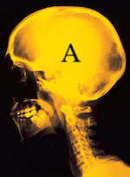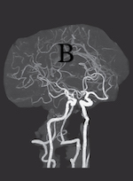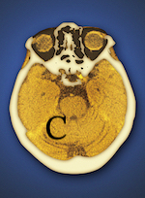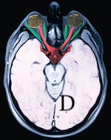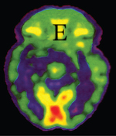
a: U.H.B. Trust/The Image Bank/Getty Images; b: pang_oasis/Shutterstock; c: Miriam Maslo/Science
Source; d: UHB Trust/Getty Images; e: ISM/Sovereign/Medical Images
Question Details
Type : New
Type : Anatomy
Activity Type : Clinical Application
Figure : 01.11

72.1) Which image is produced using an X-ray?
A) A
B) B
C) C
D) D
E) E
Question Details
Section : 01.07
Bloom's : 1. Remember
Type : New
Type : Anatomy
Activity Type : Clinical Application
Figure : 01.11

72.2) Which image is produced using Computed Tomography?
A) A
B) B
C) C
D) D
E) E
Question Details
Section : 01.07
Bloom's : 1. Remember
Type : New
Type : Anatomy
Activity Type : Clinical Application
Figure : 01.11

72.3) Which image is produced using Magnetic Resonance Imaging?
A) A
B) B
C) C
D) D
E) E
Question Details
Section : 01.07
Bloom's : 1. Remember
Type : New
Type : Anatomy
Activity Type : Clinical Application
Figure : 01.11

72.4) Which imaging technique would be used to determine the location of a blocked artery?
A) A
B) B
C) C
D) D
E) E
Question Details
Bloom's : 3. Apply
Section : 01.07
Type : New
Type : Anatomy
Activity Type : Clinical Application
Figure : 01.11

72.5) Which imaging technique would be used to determine the metabolically active areas of the brain?
A) A
B) B
C) C
D) D
E) E
Question Details
Bloom's : 3. Apply
Section : 01.07
Type : New
Type : Anatomy
Activity Type : Clinical Application
Figure : 01.11

73) 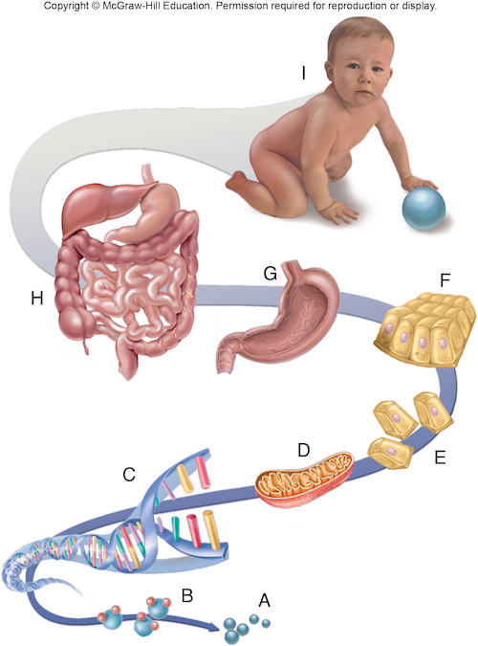
Question Details
Section : 01.05
Learning Outcome : 01.05a List the levels of human structure from the most complex to the simplest.
Type : New
Type : Anatomy
HAPS Topic : Module A06 Levels of organization
HAPS Outcome : A06.01 Describe, in order from simplest to most complex, the major levels of organizat
Topic : Body Orientation
Figure : 01.05

73.1) What level of structural hierarchy is represented by the letter E?
A) Organelle
B) Cell
C) Tissue
D) Organ
E) Molecule
Question Details
Section : 01.05
Learning Outcome : 01.05a List the levels of human structure from the most complex to the simplest.
Bloom's : 1. Remember
Type : New
Type : Anatomy
HAPS Topic : Module A06 Levels of organization
HAPS Outcome : A06.01 Describe, in order from simplest to most complex, the major levels of organizat
Topic : Body Orientation
Figure : 01.05

73.2) What level of structural hierarchy is represented by the letter H?
A) Organ system
B) Cell
C) Tissue
D) Organ
E) Molecule
Question Details
Section : 01.05
Learning Outcome : 01.05a List the levels of human structure from the most complex to the simplest.
Bloom's : 1. Remember
Type : New
Type : Anatomy
HAPS Topic : Module A06 Levels of organization
HAPS Outcome : A06.01 Describe, in order from simplest to most complex, the major levels of organizat
Topic : Body Orientation
Figure : 01.05

73.3) What is the study of the structure at E called?
A) Cytology
B) Histology
C) Physiology
D) Organismal biology
E) Pathology
Question Details
Bloom's : 2. Understand
Section : 01.05
Learning Outcome : 01.05a List the levels of human structure from the most complex to the simplest.
Type : New
Type : Anatomy
HAPS Topic : Module A06 Levels of organization
HAPS Outcome : A06.01 Describe, in order from simplest to most complex, the major levels of organizat
Topic : Body Orientation
Figure : 01.05

73.4) What is the study of the structure at F called?
A) Cytology
B) Histology
C) Physiology
D) Organismal biology
E) Pathology
Question Details
Bloom's : 2. Understand
Section : 01.05
Learning Outcome : 01.05a List the levels of human structure from the most complex to the simplest.
Type : New
Type : Anatomy
HAPS Topic : Module A06 Levels of organization
HAPS Outcome : A06.01 Describe, in order from simplest to most complex, the major levels of organizat
Topic : Body Orientation
Figure : 01.05

73.5) The integumentary system is an example of which level of structural hierarchy?
A) A
B) C
C) E
D) H
E) I
Question Details
Bloom's : 3. Apply
Section : 01.05
Learning Outcome : 01.05a List the levels of human structure from the most complex to the simplest.
Type : New
Type : Anatomy
HAPS Topic : Module A06 Levels of organization
HAPS Outcome : A06.01 Describe, in order from simplest to most complex, the major levels of organizat
Topic : Body Orientation
Figure : 01.05

73.6) A lymph node is an example of which level of structural hierarchy?
A) G
B) C
C) E
D) H
E) I
Question Details
Bloom's : 3. Apply
Section : 01.05
Learning Outcome : 01.05a List the levels of human structure from the most complex to the simplest.
Type : New
Type : Anatomy
HAPS Topic : Module A06 Levels of organization
HAPS Outcome : A06.01 Describe, in order from simplest to most complex, the major levels of organizat
Topic : Body Orientation
Figure : 01.05

73.7) A ribosome is an example of which level of structural hierarchy?
A) A
B) C
C) E
D) H
E) D
Question Details
Bloom's : 3. Apply
Section : 01.05
Learning Outcome : 01.05a List the levels of human structure from the most complex to the simplest.
Type : New
Type : Anatomy
HAPS Topic : Module A06 Levels of organization
HAPS Outcome : A06.01 Describe, in order from simplest to most complex, the major levels of organizat
Topic : Body Orientation
Figure : 01.05

74) 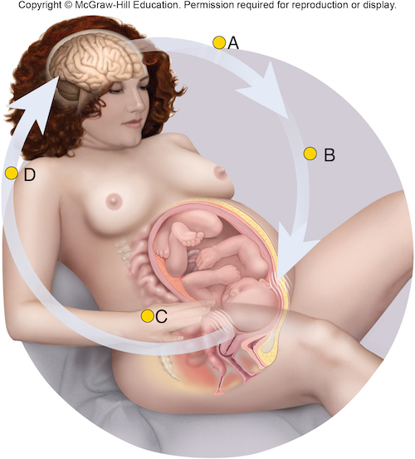
Question Details
Type : New
Type : Physiology
Figure : 01.09

74.1) This is an example of which of the following?
A) Positive feedback
B) Negative feedback
C) Dynamic equilibrium
D) Adaptation
E) Natural selection
Question Details
Section : 01.06
Learning Outcome : 01.06e Define positive feedback and give examples of its beneficial and harmful ef
Topic : Definition of homeostasis
Bloom's : 1. Remember
Type : New
Type : Physiology
HAPS Topic : Module B01 Definition of Homeostasis
HAPS Outcome : B02.03 Compare and contrast positive and negative feedback in terms of the relationshi
Figure : 01.09

74.2) In this feedback loop, what is the receptor?
A) Brain
B) Oxytocin
C) Uterus
D) Ovaries
E) Adrenal gland
Question Details
Section : 01.06
Learning Outcome : 01.06e Define positive feedback and give examples of its beneficial and harmful ef
Topic : Definition of homeostasis
Bloom's : 1. Remember
Type : New
Type : Physiology
HAPS Topic : Module B01 Definition of Homeostasis
HAPS Outcome : B02.03 Compare and contrast positive and negative feedback in terms of the relationshi
Figure : 01.09

74.3) In this feedback loop, what is the effector?
A) Cervix
B) Brain
C) Oxytocin
D) Uterine muscles
E) Ovaries
Question Details
Bloom's : 3. Apply
Section : 01.06
Learning Outcome : 01.06e Define positive feedback and give examples of its beneficial and harmful ef
Topic : Definition of homeostasis
Type : New
Type : Physiology
HAPS Topic : Module B01 Definition of Homeostasis
HAPS Outcome : B02.03 Compare and contrast positive and negative feedback in terms of the relationshi
Figure : 01.09

75) Feeling for swollen lymph nodes is an example of auscultation.
⊚ true
⊚ false
Question Details
Section : 01.01
Learning Outcome : 01.01b Describe several ways of studying human anatomy.
Gradable : automatic
Accessibility : Keyboard Navigation
Topic : Scope of anatomy and physiology
Bloom's : 1. Remember
Type : Anatomy
HAPS Topic : Module A05 Basic terminology

76) We can see through bones with magnetic resonance imaging (MRI).
⊚ true
⊚ false
Question Details
Section : 01.01
Learning Outcome : 01.01b Describe several ways of studying human anatomy.
Gradable : automatic
Accessibility : Keyboard Navigation
Topic : Scope of anatomy and physiology
Bloom's : 1. Remember
Type : Anatomy
HAPS Topic : Module A05 Basic terminology

77) Histology is the study of structures that can be observed without a magnifying lens.
⊚ true
⊚ false
Question Details
Section : 01.01
Learning Outcome : 01.01b Describe several ways of studying human anatomy.
Gradable : automatic
Accessibility : Keyboard Navigation
Topic : Scope of anatomy and physiology
Bloom's : 1. Remember
Type : Anatomy
HAPS Topic : Module A06 Levels of organization
HAPS Outcome : A06.01 Describe, in order from simplest to most complex, the major levels of organizat

78) Cells were first named by microscopist Robert Hooke.
⊚ true
⊚ false
Question Details
Section : 01.02
Learning Outcome : 01.02b Describe the contributions of some key people who helped to bring about thi
Gradable : automatic
Accessibility : Keyboard Navigation
Topic : Origins of biomedical science
Bloom's : 1. Remember
HAPS Topic : Module A06 Levels of organization

79) All functions of the body can be interpreted as the effects of cellular activity.
⊚ true
⊚ false
Question Details
Section : 01.02
Learning Outcome : 01.02b Describe the contributions of some key people who helped to bring about thi
Bloom's : 2. Understand
Gradable : automatic
Accessibility : Keyboard Navigation
Topic : Origins of biomedical science
Type : Physiology
HAPS Topic : Module A06 Levels of organization
HAPS Outcome : A06.01 Describe, in order from simplest to most complex, the major levels of organizat

80) The hypothetico-deductive method is common in physiology, whereas the inductive method is common in anatomy.
⊚ true
⊚ false
Question Details
Bloom's : 3. Apply
Section : 01.03
Learning Outcome : 01.03a Describe the inductive and hypothetico-deductive methods of obtaining scien
Gradable : automatic
Accessibility : Keyboard Navigation
Topic : Scientific Method

81) An individual scientific fact has more information than a theory.
⊚ true
⊚ false
Question Details
Section : 01.03
Bloom's : 2. Understand
Learning Outcome : 01.03c Explain what is meant by hypothesis, fact, law, and theory in science.
Gradable : automatic
Accessibility : Keyboard Navigation
Topic : Scientific Method
HAPS Topic : Module A05 Basic terminology

82) Evolutionary (Darwinian) medicine traces some of our diseases to our evolutionary past.
⊚ true
⊚ false
Question Details
Section : 01.04
Learning Outcome : 01.04a Explain why evolution is relevant to understanding human form and function.
Gradable : automatic
Accessibility : Keyboard Navigation
Topic : Human origins and adaptations
Bloom's : 1. Remember

83) The terms development and evolution have the same meaning in physiology.
⊚ true
⊚ false
Question Details
Bloom's : 3. Apply
Section : 01.04
Learning Outcome : 01.04b Define evolution and natural selection.
Gradable : automatic
Accessibility : Keyboard Navigation
Topic : Human origins and adaptations
Type : Physiology

84) Organs are made of tissues.
⊚ true
⊚ false
Question Details
Section : 01.05
Learning Outcome : 01.05a List the levels of human structure from the most complex to the simplest.
Gradable : automatic
Accessibility : Keyboard Navigation
Topic : Scope of anatomy and physiology
Bloom's : 1. Remember
Type : Anatomy
HAPS Topic : Module A06 Levels of organization
HAPS Outcome : A06.01 Describe, in order from simplest to most complex, the major levels of organizat

85) A molecule of water is more complex than a mitochondrion (organelle).
⊚ true
⊚ false
Question Details
Bloom's : 3. Apply
Section : 01.05
Learning Outcome : 01.05a List the levels of human structure from the most complex to the simplest.
Gradable : automatic
Accessibility : Keyboard Navigation
Topic : Scope of anatomy and physiology
Type : Anatomy
HAPS Topic : Module A06 Levels of organization
HAPS Outcome : A06.01 Describe, in order from simplest to most complex, the major levels of organizat

86) Homeostasis and occupying space are both unique characteristics of living things.
⊚ true
⊚ false
Question Details
Bloom's : 3. Apply
Section : 01.06
Learning Outcome : 01.06a State the characteristics that distinguish living organisms from nonliving
Gradable : automatic
Accessibility : Keyboard Navigation
Topic : Scope of anatomy and physiology
Type : Physiology

87) Negative feedback is a self-amplifying chain of events that tends to produce rapid change in the body.
⊚ true
⊚ false
Question Details
Bloom's : 2. Understand
Section : 01.06
Learning Outcome : 01.06d Define negative feedback, give an example of it, and explain its importance
Gradable : automatic
Accessibility : Keyboard Navigation
Topic : Types of homeostatic mechanisms
Type : Physiology
HAPS Topic : Module B02 General types of homeostatic mechanisms
HAPS Outcome : B02.03 Compare and contrast positive and negative feedback in terms of the relationshi

88) Positive feedback helps to restore normal function when one of the body's physiological variables gets out of balance.
⊚ true
⊚ false
Question Details
Bloom's : 2. Understand
Section : 01.06
Learning Outcome : 01.06e Define positive feedback and give examples of its beneficial and harmful ef
Gradable : automatic
Accessibility : Keyboard Navigation
Topic : Types of homeostatic mechanisms
Type : Physiology
HAPS Topic : Module B02 General types of homeostatic mechanisms
HAPS Outcome : B02.03 Compare and contrast positive and negative feedback in terms of the relationshi

89) Anatomists around the world adhere to a lexicon of standard international terms which stipulates both Latin names and accepted English equivalents.
⊚ true
⊚ false
Question Details
Section : 01.07
Learning Outcome : 01.07a Explain why modern anatomical terminology is so heavily based on Greek and
Gradable : automatic
Accessibility : Keyboard Navigation
Topic : Scope of anatomy and physiology
Bloom's : 1. Remember
Type : Anatomy
HAPS Topic : Module A05 Basic terminology

90) Lou Gehrig disease is the eponym for Amyotropic Lateral Sclerosis, made famous by the "ice bucket challege."
⊚ true
⊚ false
Question Details
Bloom's : 3. Apply
Section : 01.07
Learning Outcome : 01.07b Recognize eponyms when you see them.
Gradable : automatic
Accessibility : Keyboard Navigation
Topic : Scope of anatomy and physiology
Type : Anatomy
HAPS Topic : Module A05 Basic terminology

91) Sometimes anatomical terms come from origins that do not lend any insight into their meaning.
⊚ true
⊚ false
Question Details
Section : 01.07
Learning Outcome : 01.07e State some reasons why the literal meaning of a word may not lend to insigh
Gradable : automatic
Accessibility : Keyboard Navigation
Topic : Scope of anatomy and physiology
Bloom's : 1. Remember
Type : Anatomy
HAPS Topic : Module A05 Basic terminology

Answer Key
Test name: Chapter 01 Test Bank
1) B
2) E
3) D
4) D
5) A
6) A
7) C
8) E
9) D
10) E
11) A
12) C
13) B
14) C
15) B
16) B
17) D
18) B
19) D
20) D
21) E
22) A
23) D
24) B
25) E
26) C
27) E
28) E
29) B
30) B
31) C
32) D
33) B
34) E
35) C
36) E
37) E
38) B
39) C
40) D
41) D
42) C
43) C
44) C
45) C
46) E
47) A
48) C
49) A
50) A
51) A
52) B
53) A
54) A
55) A
56) A
57) A
58) A
59) D
60) A
61) E
62) A
63) A
64) A
65) B
66) D
67) B
68) C
Go to APR 3.0 for further information.
69) D
Go to APR 3.0 for further information.
70) Section Break
70.1) B
70.2) D
70.3) E
70.4) A
71) Section Break
71.1) A
71.2) D
71.3) B
71.4) C
72) Section Break
72.1) A
72.2) C
72.3) D
72.4) B
72.5) E
73) Section Break
73.1) B
73.2) A
73.3) A
73.4) B
73.5) D
73.6) A
73.7) E
74) Section Break
74.1) A
74.2) A
74.3) D
75) FALSE
76) TRUE
77) FALSE
78) TRUE
79) TRUE
80) TRUE
81) FALSE
82) TRUE
83) FALSE
84) TRUE
85) FALSE
86) FALSE
87) FALSE
88) FALSE
89) TRUE
90) TRUE
91) TRUE

